Analyzing Test Automation Frameworks

A Work Term Report By: Johnson Nguyen
Submitted: December 2015 from T2 Systems Canada

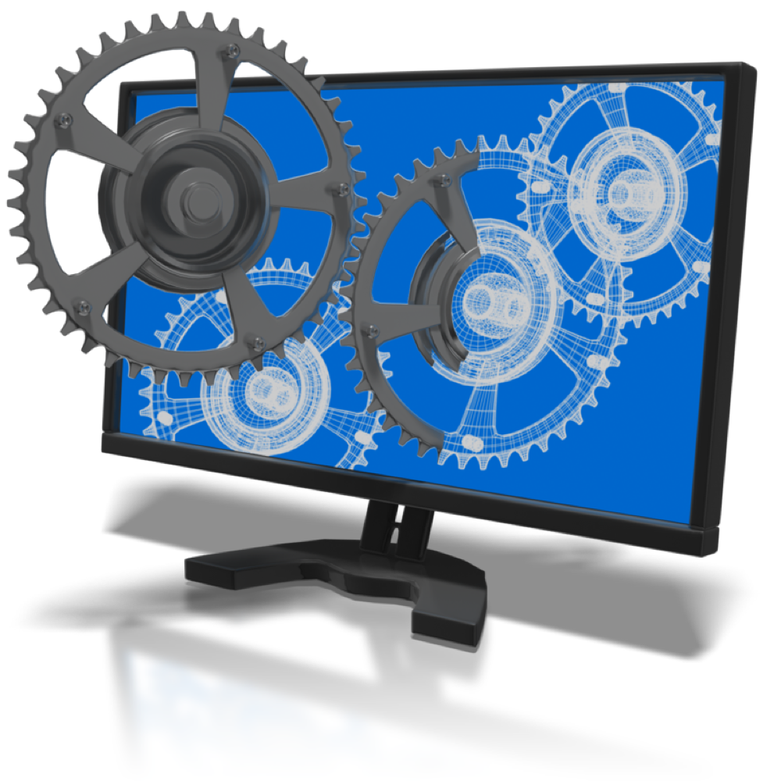

Summary
This report discusses about analyzing test automation frameworks, a process I had to perform during my co-op term in order to find a suitable framework to write automation tests that could replace the current one we had. The report introduces to the reader to some of the common tools found only in T2 Systems and available for potential customers, including pay stations and the software tool that comes with it, Digital Iris. The main purpose of this report however, is to discuss why the current framework we have for test automation does not suit our needs and what was our solution to replace the tool we had so far. This report will also introduce some of the frameworks discovered during the course of this analysis, some of which may provide use to some others as they already have. This report will mainly go over the problems we had with our old framework, Nightwatch, and how our current one, Robot, is able to remedy most of those issues.



Table Of Contents: Page:
- Introduction
- Gathering Requirements/Issues With Nightwatch
- Finding Automation Frameworks
- Automation Framework Analysis/Deciding On Robot
- The Automation Plan
- Conclusion
- References

Introduction:
Even to this day, T2 Systems Canada have done most of their testing manually through pressing buttons on the software’s UI, running simulator tools manually etc… There are even make-shift paystations set up on desks to go along with the manual testing, which are mainly used to perform transactions and seeing that transaction become data that is shown on Digital Iris. While we began to have some automation involved, mainly for UI testing, the majority of our testing is done manually. Naturally, manual testing can be quite inefficient and costly. While it can be thorough, it can also can be time-consuming, repetitive, and even tedious at times. This goes especially true for smoke and acceptance-level tests, where they are run often. With the QA team at T2 Systems, even the smoke-level tests which simply ensures that the main components of the system are working can take a few hours to run with the whole team. At T2 Systems, smoke-level tests are ran often. This is why, the QA team is looking for a framework that can automate the whole smoke-level testing process for them. This way, the QA team can run all the smoke tests that is normally a manual process, with simply a press of a button, followed by a wait as all the automated tests are run. In the meantime, QA can move onto other, more important tasks as they wait for the automated smoke tests to finish and publish the result. This is the goal that we had set for ourselves at the beginning. Afterwards, the goal would be to cover acceptance-level testing, bug fix testing, etc.... It was originally believed that we could achieve our initial goal with Nightwatch, an automated web-browsing testing framework written in Javascript. However, the more we used it, the more we realized its limitations. That's why, the team went on to research and analyze the other frameworks available on the net and select the right one to suit our needs.
-Brief Terminology:
- Pay Stations - The stations that you would find anywhere when you have to pay for parking. The one marked with the logo ‘DPT’, ‘Digital Paytech’ or anything along those lines originated from T2 Systems Canada, formerly known as Digital Payment Technology
- Digital Iris - The name of the website/software we have to manage parking data, set rates and monitor pay stations for our customers. Access available to any customer that purchases T2 systems’ products, such as pay stations.

Gathering Requirements:
There are a lot of automation testing tools available on the net, each with its own list of pros and cons and suited for different types of people. It would be pointless and time-consuming to search through each one to find the right one to use for you and your team. That's why, the first thing we do is gather up a list of requirements that describes the kind of testing framework we're looking for. If this is your first automation framework, then coming up with that list can be rather difficult.
Fortunately, the QA team at T2 Systems already has some experience with automating web-browser actions with a framework called Nightwatch.js. At the beginning, this framework showed promise but the more we used it, the more issues we came across both in test script execution as well as its capability. However, it was Nightwatch's lack of documentation on the web as well as the fact that it runs on javascript (a rather difficult language to understand, especially for the QA Team, who is to be blunt, not very code-savvy) that limited the team's ability to use it effectively. Aside from one person, there wasn't anyone who could use or understand the tool well at T2.
So, by finding the flaws and limitations of Nightwatch, we were able to use that as a guideline to come up with the initial requirements for the framework we're looking for. In other words, we want a framework that can do what Nightwatch couldn't, and what Nightwatch could do, the new framework can do better.
During my run with Nightwatch, these were the issues that were commonly brought up as I tried to develop and run test scripts. Keep in mind that this list comes from a subjective viewpoint. Others can see these issues as a plus:
Known NightwatchIssues:
- Lack of resources online that could be used to troubleshoot issues.
- Lack of functionality. It can only perform UI functions as well as some XMLRPC.
- Occasionally, nightwatch scripts will fail as it neglects to perform some actions.
- Tests are skipped (under investigation if this is a selenium, Jenkins or nightwatch issue)
- Tests are run in-serial
- Test Reports/Logs are not clear.
- Nightwatch is limited to Javascript
- Firefox Only
- Debugging Issue. If there's an issue in the script, Nightwatch will not be very clear on what that issue is.
- Parallel script execution is not possible because it would require additional Selenium servers. Current configuration is one NightWatch client per selenium server.
- Web elements are identify by Xpath and CSS.
Because of these issues we found in using Nightwatch, that we were able to quickly come up with a list of requirements for an automation framework that can remedy the problems we ran into with Nightwatch.
The Acceptance Criteria for the desired functionality for our automation framework became as such:
Acceptance Criteria:
This is the desired framework(s) functionality:
- Can work with Gits, Maven and Jenkins
- Execute scripts in parallel
- Framework and scripts be browser independent. Can run on any browsers.
- Clear Reports and Logs
- Front UI Automation, API Automation and Database
- Continuous integration testing
- Automatic + Manual Execution
- Tests are written as self-contained(perform a setup and teardown step and can be run independently)
- Tests are fast(to write up, implement and maintain, as well as run).
- Reasonably easy to learn
- Well supported framework with plenty of documentations.
- Ease of script maintenance and maintainability
- Runs on Python

As you can see, some of the items on this list are basically the issues found in Nightwatch turned into a requirement for our new framework. The rest are additional that came up in the midst of writing these requirements. Of course, we only research automation frameworks because we're lacking knowledge on it. So this list of requirements may be incomplete for all we know and there could be other functionality we may desire but haven't considered. However, that will come with time and experience and the items we have now are a good start in narrowing down the list of possible frameworks we can choose from.
Now, to satisfy every requirement would be like a dream but sometimes, reality isn't as nice. So we had to prioritize which of the desired functionality we absolutely need in our framework and ones we can do without.
A glaring issue we had with Nightwatch was that it lacked documentation, can only work with Firefox and tests have a tendency to be dependent of other tests. So we prioritized on a framework with plenty of documentation, runs on Python, can work on any browser and each test can be written independently.
Those were the must-have items on our list, along with a few others.We desired Python as the programming language for our automation framework because not only is it easy-to-use, especially for new and inexperienced programmers, but Python has proven to have a lot of capabilities.
Once the requirements were gathered, we then decided what kind of test scripts to write for the new frameworks to demonstrate their capabilities.
Digital Iris has plenty of features and therefore, plenty of things we can test and even more test scenarios we can create for those features. For the sake of analyzing frameworks however, we kept it to two different but commonly usedfeatures:
1. Customer Account Creation
2. XMLRPC: Credit Card Transaction
These features were chosen because not only are they used often, but creating these two will cover much of what needs to be automated in the future. If we can get these features working, the rest would be straight-forward.
Once the requirements were gathered, we went on to actually looking for a framework on the net that can fulfill our acceptance criteria.

Finding Automation Frameworks
The net is a large place, so large that it would be difficult to know where to begin searching.
Thankfully, because of the list of requirements we came up for our Acceptance Criteria, we can narrow our search significantly.
Since we're looking for automation frameworks that run on Python, that is the first thing we search for. Luckily, there is already a site provided with a full list of all known Testing Frameworks written in Python.
Link To List Of Testing Frameworks For Python: https://wiki.python.org/moin/PythonTestingToolsTaxonomy
Afterwards, it became a matter of going through the list and searching for the framework we want.
The list of Frameworks in the link provided above was also divided between the types of testing tools (i.e. Unit Testing Tools, Web Testing Tools etc....)
We dabbled with a few unit testing frameworks such asunittest and py.test but it was clear that we needed a tool that can perform Acceptance/Business Logic Level Testing as unit tests are a form of testing mostly done for developers. For QA, it's our job to ensure that a feature passes its Acceptance Criteria and that a feature is performing the correct behavior. To automate that, we need a tool that can test the system on more of a business level and automate the behaviour of a user going into a system and performing a series of actions and verifying results.
With that in mind, we narrowed our search to three potential frameworks, all convenient placed in a table labelled: "Acceptance/Business Logic Testing Tools" in the link above.
Those frameworks are:
1. Robot Framework
2. Lettuce
3. behave

Automation Framework Analysis
To analyze the framework is obviously to read the documentation. The site for each framework highlights the overall features quite well and you can get decent coverage on its capabilities from reading any tutorials or quickstart guides. Then, we should actually try and use it, run some tutorials, write some sample scripts and then record the observations, along the way. Looking into the three frameworks chosen, these were the observations and facts discovered:

Robot Framework
Link: http://robotframework.org/
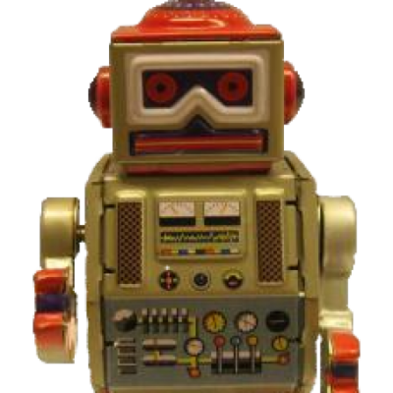
Pros:
- Supports Jenkins and Maven
- Generates a Test Report and Log after each test run
- Lots of built-in and external libraries available.
- Libraries can be written in Python or Java.
- Installation is easy and lots of options available
- Possesses Markdown language that is data-driven. New test cases for simular functions can be made easy with one line in a script
- Markdown itself is easy to understand and can be used to expand test cases.
- Can support any browser
- Has a selenium library that can be used to call Web Browser actions. Selenium Library is already written in Python and easy to use as users simply call in keywords and fill in the parameters for them. It is essentially cheating.
- Test cases can be keyword-driven or data-driven.
- Markdown language can be written in a variety of formats, including, HTML, TSV and Plain text.
- Tests generally written in a table format
- Tests can be easily self-contained. Test Suites can also be self-contained and defined in a single script, allowing a setup and teardown script in a test suite.
- Can switch between element locators such as xpath and css easily
- Plenty of element locator options to use
- Strings can be appended easily.
- Creating tests with arguments is simple
- Python libraries can be re-run as many times once it's been created and easy to maintain.
- Scripts themselves run overall faster than Nightwatch
- On test failure, Selenium will save a screenshot of the web browser where the error occurred.
- Running tests in parallel is possible. Robot has a parallel executor called Pabot that can be used: https://github.com/mkorpela/pabot

Cons:
- Does not support Python 3 quite yet (Can be remedied by an unofficial Python 3 port that is available however)
- The command to run it on Linux Environment is different compared to the window's instruction.
- Not pure Python as it uses a built-in Markdown language to run test cases.
- Will not run Python script directly.
- Very high learning curve compared to Nightwatch, due to needing to learn both Python and the Markdown and how the components interact with each other, especially when attempting to create high level custom libraries.
- Robot Framework offers a lot of choices as to how a person can write these test cases; documentation can be confusing.
- Creating custom libraries is a bit of a challenge and time-consuming.
- Can suffer the same timeout issues as Nightwatch if not careful
- From what has been seen so far, some items on a page don't timeout so a page reload is sometimes necessary.
- Like Nightwatch, tests can fail as a result of performance issues, especially when dealing with different browsers

Other Notes:
- Performance of tests can depend on browser (ex. Firefox runs notably faster than Internet Explorer)

Lettuce Framework

Link: http://lettuce.it/tutorial/simple.html
Pros:
- Tests are written in pure Python scripting
- The tests are very behavior driven
- tests can be run in a suite.
- Has an addition .feature file, written in plain English, that can easily be understood and used to call the test steps written in Python with parameters.
- Tests can be very data-driven
- Test results are quite simple and easy to read. Failures in the test can be found immediately. Success rate is printed by feature, scenario and finally, steps.
- Installation is easy, simply 'pip install lettuce' using a linux command prompt.
- Not much needed to know about Lettuce itself. Most learning will be done at looking Python language as a whole
- If familiar with Cucumber, the Lettuce feature file should be easy to use since its based off of Cucumber framework.
- Good for testing scenarios of a particular feature, supporting scenario outlines so that multiple tests can be added with a single line
- a step written in python can be reused multiple times
- Simple and easy to use, coding in Python is straightforward.
- Can group up steps into classes.

Cons:
- The framework looks relatively new, so resources may be limited.
- Simply compares the result with expected. Leetuce will require other tools, like Selenium, to do more actions like testing UI browser.
- If not familiar with Cucumber, then learning the .feature file can be considered another learning curve.
- Hardcoded strings would require manual updates when any related step-definitions has its regex changed.
- Step definitions that are multiple-lines long now just bypass the parameters into single-line function calls.
- When the hardcoded string has typos, no syntax error will occur yet the test will fail with a misleading error message.
- if you have to bypass parameters to the target steps, you will need to concatenate or interpolate strings, which will easily become a mess.
- if the string you pass as a parameter has typos, it’s a pain to debug.
- To pass parameters, a good knowledge of regex expression is required
- Lettuce never cleans up its world variables. It just assumes anything you put there should be left there forever. This allows you to easily confuse downstream steps with upstream global pollution. Your triage procedure will probably rely on using hooks to unset individual variables in world.
- Passing arguments can be confusing
- Documentation is limited.

behave Framework(similar to Lettuce, but with some differences) in terms of functionality)
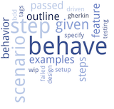
Link: http://pythonhosted.org/behave/
Pros:
- Tests are written in pure Python scripting
- The tests are very behavior driven
- tests can be run in a suite.
- Has an addition .feature file, written in natural language, that can easily be understood and used to call the test steps written in Python with parameters.
- Tests can be very data-driven
- Test results are quite simple and easy to read.
- Installation is easy, simply 'pip install lettuce' using a linux command prompt.
- Not much needed to know about Lettuce itself. Most learning will be done at looking Python language as a whole
- Good for testing scenarios of a particular feature, supporting scenario outlines so that multiple tests can be added with a single line
- a step written in python can be reused multiple times
- Simple and easy to use, coding in Python is straightforward.
- Has lots of resources available to use.
- Anyone can write a features file, whether they are Business Analysts, or QA
- behave encourages a more structured test directory for testing a specific feature. Example: features/
features/signup.feature
features/login.feature
features/account_details.feature
features/environment.py
features/steps/
features/steps/website.py
features/steps/utils.py
- Documentation is clear and detailed.
- feature file good for describing the overall behavior of the test
- no need to clarify which steps file to use for a particular feature as it'll use all of them.
- parameters for a step are easier to define than Lettuce.
- has a context variable which is used by behave to store information to share around between test steps and scenarios
- Can create 'setup' steps to be run before testing a feature, scenario etc... and tags to run specific scenarios
Cons:
- Test results aren't as detailed or color-coded as the other frameworks
- Simply compares the result with expected. behave will require other tools, like Selenium, to do more actions like testing UI browser.
- Learning the .feature file can be considered another learning curve.

Deciding On Robot
As you can see, there is no automation framework that is perfect. All these frameworks have their ups and downs and they each are used differently from each other. Nevertheless, these 3 frameworks still satisfy a majority of our Acceptance Criteria and are all valid frameworks that we can use. So, which one should we pick?
It all boils down to a few questions to yourself:
What kind of people will be using this framework? What kind of people will be trying to learn it? Will they be able to overcome the learning curve?
These questions will make you look more at your team rather than the frameworks. It won’t be just one person writing these scripts, other people need to be able to write them as well. So, the real question is which framework is the best for those people in mind. For the QA team at T2 Systems Canada, who aren’t strong with coding, it was perceived that the Robot Framework, was our best option for a new testing framework, mostly because it provides many python libraries that performs the task we required and wouldn’t have to implement ourselves.
It is our hope that Robot really is that tool that T2 seeks, or at least, we discover it isn't early-on, as the more time that we put into integrating the tool, on top of the time spent already searching for it, it'll become harder for us to repeat the process again. At the very least, we do not want to waste months of effort developing Robot Scripts, only to realize that this tool isn't what we want. That's why during the analysis of the automation frameworks, we needed to have near-absolute confidence in our decision in picking Robot, which is the main factor why our automation research took up so much time (nearly a month, actually).

There was a challenge in trying to use the Markdown, and lots of discussions were held in trying to establish an automation structure and workflow but thankfully, there were a lot of documentation available for Robot Framework to help guide new users. The rest from there comes with time and experience. With enough experience in script writing, you should be able to create multiple test case scenarios that relies on a single script and you will be able to write a script that performs a certain action only once.
Interestingly enough, there has yet to be a reason for the QA team to create their own Python Libraries. Robot Framework has so many external python libraries available developed by other people that the QA team merely needs to take advantage of the available tools and use them to develop their scripts. That is the main strength of Robot.
To have a better understanding at how versatile it is, here’s an image of all the external libraries available to be used in Robot:
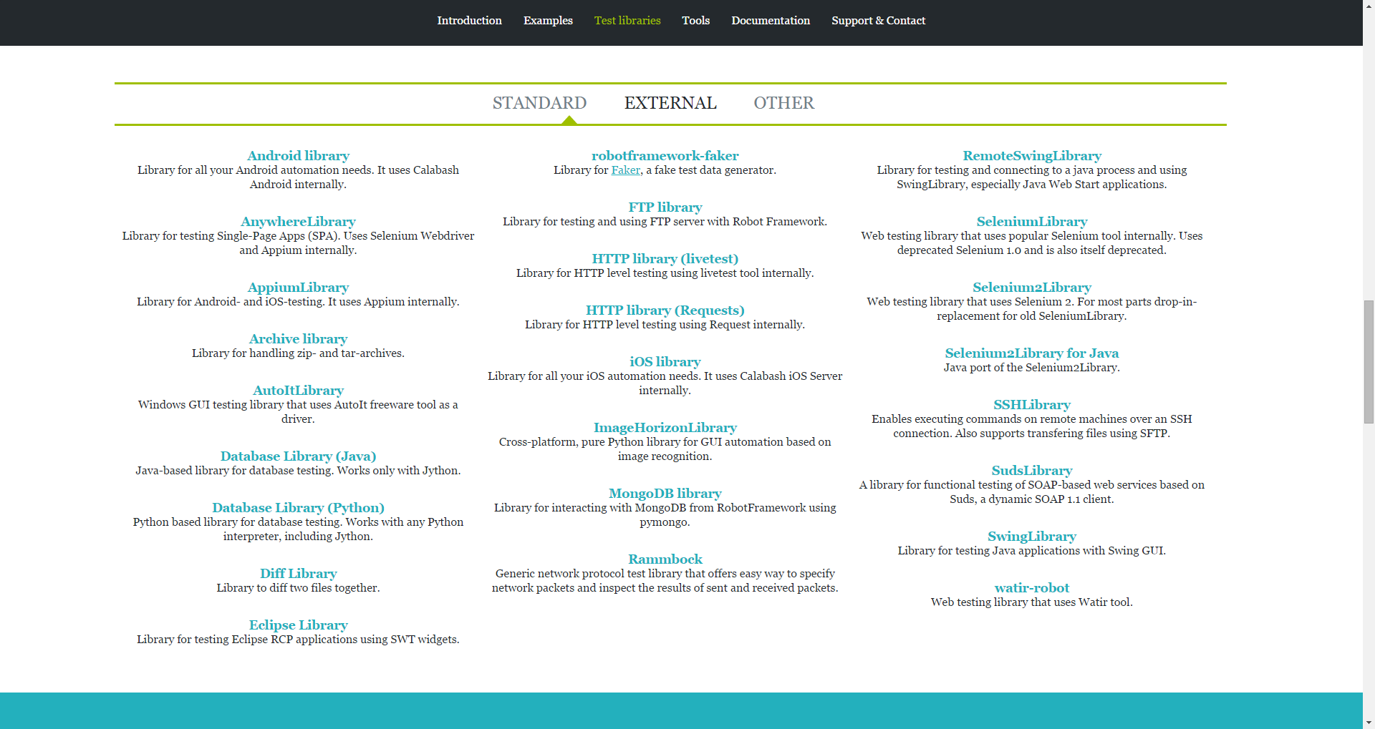
This is for External (aka third-party) libraries alone. Robot Framework also has the standard libraries to perform String, DateTime operations etc…These are a lot of libraries, and the QA team has only touched about 1 or 2 of them at most. Our test coverage will expand as we automate more things but Robot Framework has so many libraries that the chances are good that we will be able to find a library that covers the functionality we need in future tests.
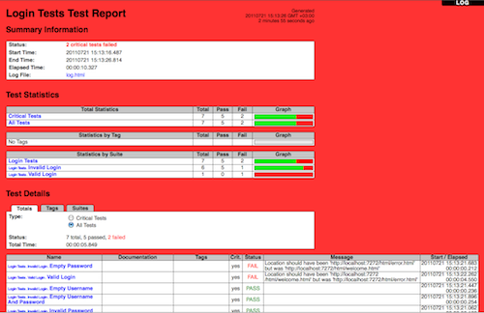
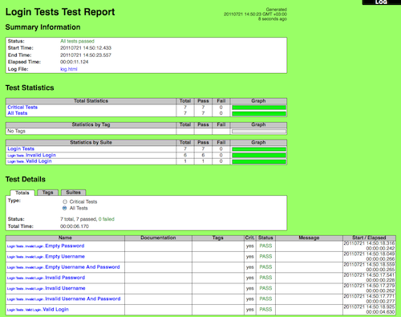
Another useful feature is that Robot will produce a log/report in HTML format that is easy-to-read and highlight in details whether the tests passes (green) or fails (red) with detailed messages about where and why the test failed.

Robot Framework has a bit of learning curve, however. Since, it uses a special Markdown language that is rarely used anywhere else, even experienced programmers in other languages will need some time adjusting to this new style of test case writing.
However, it more than pays off. With all of Robot Framework’s functionality as once the Markdown language has been learned, writing scripts would get easier and easier and the scripts you can create would be easy to maintain and re-use.
The hope with Robot is not only to replace Nightwatch as the better tool in terms of performance and functionality but to ensure that the framework satisfy all the team’s automation needs so that we would have no need to go through this time-consuming research again. Out of all the frameworks discovered, Robot seems to be the best tool for the QA team, but it has yet to be seen.

The Automation Plan
So the automation framework has been decided. Next comes the plan for the automation. Now that we decided to adopt a new framework, there are a few things we need to do.
- Teach this framework to the other members of the team
- Come up with a guideline for the script development and a means or organizing the scripts
- Begin writing actual test scripts for Iris so that it can replace the old framework and be used for regular runs like smoke testing and acceptance testing. Also, include plenty of documentation so that other people can write test scripts as well.
Teaching others to use the framework will take time. This was an issue we had even with our old framework. To try and facilitate the learning process, we tried to come up with exercise sets and tutorials to help the QA team to get some hands-on experience with writing automation scripts in Robot. Trying to get the team to integrate themselves with this tool remains a continuing challenge for they had to take up learning this new tool on top of all the work they already have in front of them. It's especially difficult for members of the team with little-to-no coding experiences as they have trouble grasping the basics. For that reason, exercise sets were devised for the sake of helping those kinds of people. Not only are they relatively straight-forward, but they were designed to teach people completely new to the framework as well as make use of the Digital Iris system we have as a sort-of sandbox to help develop interest in the team.
Coming up with a guideline for script writing as well as figuring out the folder structure to organize our scripts took a few meetings and discussions but after finding a particularly useful YouTube link (provided in references) as well as using the file structure we had for Nightwatch as a reference, we managed to come up with an initial plan for our Script Development, from variable naming conventions to how the scripts are to be organized between files. This plan is only in its initial planning and until we have more scripts to develop, is still subjected to change and suggestions.
Then, comes arguably the longest and most arduous task would be writing scripts to automate testing the many functionalities of Digital Iris. If it was just a smoke-level test then it could be done simply but since our end goal is to cover the automation of acceptance-level testing, there are many test cases that needs to be written for each feature alone and the scripts need to be written to be robust enough to handle all those cases. Until we can provide decent cover of the test automation of Iris, we will have to rely on the previous test scripts written with Nightwatch to do our automation runs until we have enough scripts written in Robot that it completely encompasses the Nightwatch coverage. This process may take months even as Digital Iris as so many features and the conversion from Nightwatch to Robot isn’t as simple as copy-pasting. Even during my work term here, I only managed to cover customer creation, paystation creation as well as sending transactions and alerts to a Paystation for Digital Iris.
Because Robot Framework has plenty of functionalities and ways we can write scripts, we had to decide on a format that the entire team can agree to so as to avoid confusion. We settled on writing Gherkin-style test cases, which is found in tools like Cucumber, lettuce, and behave.
Gherkin is the language that Cucumber understands. It is a Business Readable, Domain Specific Language that lets you describe software’s behaviour without detailing how that behaviour is implemented.
Gherkin serves two purposes — documentation and automated tests. The third is a bonus feature — when it yells in red it’s talking to you, telling you what code you should write.
Gherkin’s grammar is defined in the Treetop grammar that is part of the Cucumber codebase. The grammar exists in different flavours for many spoken languages (37 at the time of writing), so that your team can use the keywords in your own language.
The purpose of choosing to write Gherkin’s style test cases is that anyone can write test scenario for a feature, not just QA. The idea here is that we can have people from the business-side write out the test scenarios and accurately describe what the intended behavior for that feature is and the job of the QA and Developers to provide the scripts in the backend to perform that functionality.
This is the plan that we laid out for automation for T2 Systems. It’s hard to call it perfect and it’s still subjected to change as we slowly realize our limitations and find alternative, more optimal solution, but this is the overall guideline that we’re going with in terms of automation.
We’re also careful to document everything we have with Robot, this automation test plan included, so that as people in this company come and go, there will always be someone who can take up the automation work and there are plenty of resources written for T2 Systems Canada’s QA Team about Robot and even more resources about the framework as a whole on the net. Taking advantage of those available documents is how people can become proficient in using this automation framework.

Conclusion
Being given the responsibility to research and analyze new testing frameworks for the entire to use, was without a doubt, the biggest responsibility I ever taken. It was challenging, but it was a lot of fun as well. There was a lot of frustration that came with roadblocks as well as that joyous feeling you get when you overcome them. To be able to take up those tasks and rise to the occasion may just be the proudest achievement I made as of yet. Researching new testing frameworks for the company and analyzing their pros and cons was quite the time-consuming task and to avoid using that precious time up again, I hope that Robot, the framework that was chosen, becomes exactly the tool that T2 Systems Canada needs. On this road of introducing a new tool to the company, the research was actually the easy part; the difficulty comes with integrating it with the entire team. It is without a doubt, a long road but I have no regrets walking on it. However, I do regret being unable to see it through to the end. Hopefully, I had laid out a strong enough foundation and developed enough scripts for them that it kicked off the process so that the rest of the team can continue off what I started now that my co-op term has ended. The road of integrating our new automation framework, Robot, will take some time (estimating, months) and it isn't exactly an easy path to walk, based on my experiences. However, I have confidence that the entire team will be able to see this road to the end, and hope the future QA Automation co-ops working on this framework learns even more about it than I have.

References:
Behave: http://pythonhosted.org/behave/
Lettuce: http://lettuce.it/
Robot Framework Site: http://robotframework.org/
Quickstart Guide - A quick guide for new users to get accustomed to Robot -https://github.com/robotframework/QuickStartGuide/blob/master/QuickStart.rst
Web Demo - A demonstration of test creation and higher level keywords, using Selenium2Library https://bitbucket.org/robotframework/webdemo/wiki/Home
Robot Demo - A demonstration of using a custom Python Library https://bitbucket.org/robotframework/robotdemo/wiki/Home
User Guide + Important Library Documentation User Guide: http://robotframework.org/robotframework/latest/RobotFrameworkUserGuide.html
Built-In Documentation: http://robotframework.org/robotframework/latest/libraries/BuiltIn.html
Selenium2Library: http://robotframework.org/Selenium2Library/doc/Selenium2Library.html
String: http://robotframework.org/robotframework/latest/libraries/String.html
Collections: http://robotframework.org/robotframework/latest/libraries/Collections.html
Requests: http://bulkan.github.io/robotframework-requests/
Date/Time: http://robotframework.org/robotframework/latest/libraries/DateTime.html
Http Library: http://peritus.github.io/robotframework-httplibrary/HttpLibrary.html
Parallel Robot Executor: https://github.com/mkorpela/pabot

